**10**



**Technology and Livelihood Education**

**Agri-Fishery Arts**

**Food Processing**

**Quarter 2 - Module 1**

**Operating Equipment**

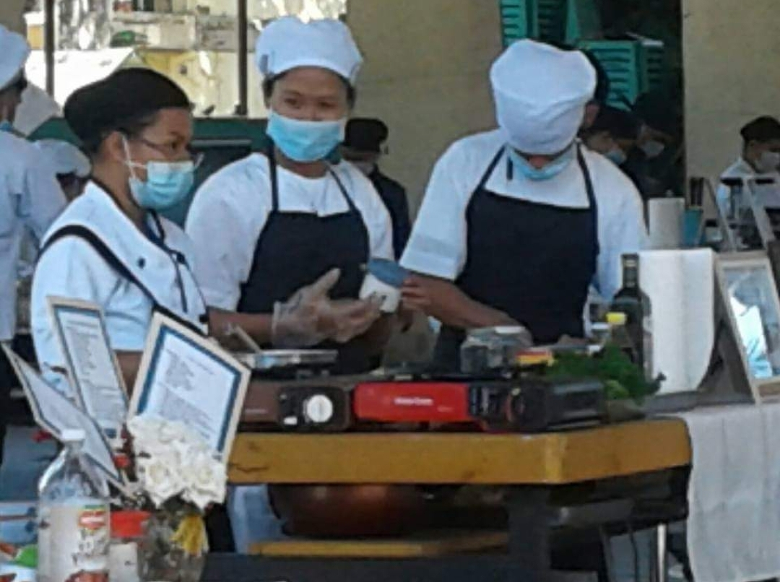

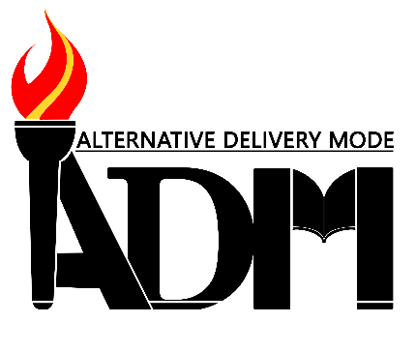



|  |  |  |  |  |
| --- | --- | --- | --- | --- |
| Image result for refrigerator |  | **ADM logo red torch**Image result for can sealer | Image result for plastic sealer |  |

**Department of Education • Republic of the Philippines**

**Technology Livelihood Education Grade 10**

**Agri-Fishery Arts - Food Processing**

**Alternative Delivery Mode**

**Quarter 2 - Module 1: Operating Equipment**

**First Edition, 2020**

**Republic Act 8293, section 176** states that: No copyright shall subsist in any work of the Government of the Philippines. However, prior approval of the government agency or office wherein the work is created shall be necessary for exploitation of such work for profit. Such agency or office may, among other things, impose as a condition the payment of royalties.

Borrowed materials (i.e., pictures, photos, brand names, trademarks, etc.) included in this module are owned by their respective copyright holders. Every effort has been exerted to locate and seek permission to use these materials from their respective copyright owners. The publisher and authors do not represent nor claim ownership over them.

Published by the Department of Education - Division of Bukidnon

**Development Team of the Module**

Writers: Mariza M. Baiῆo

Mena L. Lagrama

Editors: Teresita P. Mansueto, PhD

Helen N. Ybaῆez, PhD

Reviewer: Mary Jane R. Cardente, PhD

**Management Team:**

Chairperson: Arturo B. Bayocot, PhD, CESO III

*Regional Director*

Co-chairpersons: Victor G. De Gracia, Jr., PhD, CESO V

*Asst. Regional Director*

Randolph B. Tortola, PhD, CESO IV

*Schools Division Superintendent*

Shambaeh A. Usman, PhD

*Asst. Schools Division Superintendent*

Mala Epra B. Magnaong, Chief ES, CLMD

Neil A. Improgo, PhD, EPS-LRMS

Bienvenido U. Tagolimot, Jr., EPS-ADM

Members: Elbert R. Francisco, PhD, Chief ES, CID

Mary Jane R. Cardente, PhD, EPS TLE

Rejynne Mary L. Ruiz, PhD, LRMDS Manager

Jeny B. Timbal, PDO II

Shella O. Bolasco, Division Librarian II

Printed in the Philippines by

Department of Education - Division of Bukidnon

Office Address: Fortich Street, Sumpong, Malaybalay City, Bukidnon

Telephone: (088) 813-3634

E-mail Address: [bukidnon@deped.gov.ph](mailto:bukidnon@deped.gov.ph)

Website: depedbukidnon.net.ph

10

**Technology and Livelihood Education**

**Agri-Fishery Arts**

**Food Processing**

**Quarter 2 - Module 1**

**Operating Equipment**

This module was collaboratively developed and reviewed by educators from public schools. We encourage teachers and other education stakeholders to email their feedback, comments and recommendations to the Department of education at [bukidnon@deped.gov.ph](mailto:bukidnon@deped.gov.ph).

We value your feedback and recommendations.

# Department of Education • Republic of the Philippines

# Introductory Message

**For the Facilitator:**

Welcome to Technology and Livelihood Education Grade 10 Agri-Fishery Arts - Food Processing Alternative Delivery Mode (ADM) Module on Operating Equipment!

This module was collaboratively designed, developed and reviewed by educators both from public and private institutions to assist you, the teacher or facilitator in helping the learners meet the standards set by the K to 12 Curriculum while overcoming their personal, social and economic constraints in schooling.

This learning resource hopes to engage the learners into guided and independent learning activities at their own pace and time. Furthermore, this also aims to help learners acquire the needed 21st century skills while taking into consideration their needs and circumstances.

In addition to the material in the main text, you will also see this box in the body of the module:



***Notes to the Teacher***

This contains helpful tips or strategies that will help you in guiding the learners.

As a facilitator you are expected to orient the learners on how to use this module. Furthermore, you need to keep track of the learners' progress while allowing them to manage their own learning. Moreover, you are expected to encourage and assist the learners as they do the tasks included in the module.

**For the Learners and Parents:**

Welcome to Technology and Livelihood Education Grade 10 Agri-Fishery Arts - Food Processing Alternative Delivery Mode (ADM) Module on Operating Equipment!

The hand is one of the most symbolic part of the human body. It is often used to depict skill, action and purpose. Through our hands we may learn, create and accomplish. Hence, the hand in this learning resource signifies that you as a learner is capable and empowered to successfully achieve the relevant competencies and skills at your own pace and time. Your academic success lies in your own hands!

This module was designed to provide you with enjoyable and meaningful opportunities for guided and independent learning.

You will be enabled to process the contents of the learning resource while being an active learner.

This module has the following parts and corresponding icons:

|  |  |  |  |
| --- | --- | --- | --- |
| |  |  | | --- | --- | | C:\Users\DEPED\Desktop\ADM specs\ADM cover and icons\ADM Icons\Alamin2.jpg | ***What I Need to Know*** | | This will give you an idea of the skills or competencies you are expected to learn in the module. |
| |  |  | | --- | --- | | C:\Users\DEPED\Desktop\ADM specs\ADM cover and icons\ADM Icons\What I Know.jpg | ***What I Know*** | | This part includes an activity that aims to check what you already know about the lesson to take. If you get all the answers correct (100%), you may decide to skip this module. |
| |  |  | | --- | --- | | C:\Users\DEPED\Desktop\ADM specs\ADM cover and icons\ADM Icons\Balikan.jpg | ***What’s In*** | | This is a brief drill or review to help you link the current lesson with the previous one. |
| |  |  | | --- | --- | | C:\Users\DEPED\Desktop\ADM specs\ADM cover and icons\ADM Icons\Tuklasin.jpg | ***What’s New*** | | In this portion, the new lesson will be introduced to you in various ways such as a story, song, poem, problem opener, an activity or situation. |
| |  |  | | --- | --- | | C:\Users\DEPED\Desktop\ADM specs\ADM cover and icons\ADM Icons\suriin.jpg | ***What Is It*** | | This section provides a brief discussion of the lesson. This aims to help you discover and understand new concepts and skills. |
| |  |  | | --- | --- | | C:\Users\DEPED\Desktop\ADM specs\ADM cover and icons\ADM Icons\whats more.jpg | ***What’s More*** | | This comprises activities for independent practice to solidify your understanding and skills of the topic. You may check the answers to the exercises using the Answer Key at the end of the module. |
| |  |  | | --- | --- | | C:\Users\DEPED\Desktop\ADM specs\ADM cover and icons\ADM Icons\Isaisip.jpg | ***What I Have Learned*** | | This includes questions or close sentence/paragraph tests to process what you learned from the lesson. |
| |  |  | | --- | --- | | C:\Users\DEPED\Desktop\ADM specs\ADM cover and icons\ADM Icons\Isagawa.jpg | ***What I Can Do*** | | This section provides an activity which will help you transfer your new knowledge or skill into real life situations or concerns. |
| |  |  | | --- | --- | | C:\Users\DEPED\Desktop\ADM specs\ADM cover and icons\ADM Icons\Tayahin.jpg | ***Assessment*** | | This is a task which aims to evaluate your level of mastery in achieving the learning competency. |
| |  |  | | --- | --- | | C:\Users\DEPED\Desktop\ADM specs\ADM cover and icons\ADM Icons\Additional Activities.jpg | ***Additional Activities*** | | In this portion, another activity will be given to you to enrich your knowledge or skill of the lesson learned. This also tends retention of learned concepts. |
| |  |  | | --- | --- | | C:\Users\DEPED\Desktop\ADM specs\ADM cover and icons\ADM Icons\Answer Key 2.jpg | ***Answer Key*** | | This contains answers to all activities in the module. |

|  |  |
| --- | --- |
| ***References-*** | This is a list of all the resources used in developing this module. |

At the end of this module you will also find:

The following are some reminders in using this module:

1. Use the module with care. Do not put unnecessary mark/s on any part of the module. Use a separate sheet of paper in answering the exercises.
2. Don’t forget to answer *What I Know* before moving on to the other activities included in the module.
3. Read the instruction carefully before doing each task.
4. Observe honesty and integrity in doing the tasks and in checking your answers.
5. Finish the task at hand before proceeding to the next.
6. Lessons are prepared weekly and all answers on the given activities should be submitted every Friday of the week.
7. Return this module to your teacher/facilitator once you are through with it.

If you encounter any difficulty in answering the tasks in this module, do not hesitate to consult your teacher or facilitator. Always bear in mind that you are not alone.

We hope that through this material, you will experience meaningful learning and gain deep understanding of the relevant competencies. You can do it!

|  |  |
| --- | --- |
| **Table of Contents** | Page |
| COVER PAGE |  |
| COPYRIGHT PAGE |  |
| TITLE PAGE |  |
| INTRODUCTORY MESSAGE |  |
| TABLE OF CONTENTS |  |
| **Lesson 1.** Personal Protective Equipment and Occupational Health and Safety Requirements |  |
| What I Need to Know | 1 |
| What I Know | 1 |
| What’s In | 2 |
| What’s New | 2 |
| What it Is | 4 |
| What’s More | 5 |
| What I have Learned | 5 |
| What I Can Do | 5 |
| Assessment | 6 |
|  |  |
| **Lesson 2.** Following Manufacturers’ Specification |  |
| What I Need to Know | 7 |
| What I Know | 7 |
| What’s In | 8 |
| What’s New | 8 |
| What it Is | 11 |
| What’s More | 12 |
| What I have Learned | 12 |
| What I Can Do | 12 |
| Assessment | 13 |
|  |  |
| **Lesson 3.** Operating Specific Equipment or Machine |  |
| What I Need to Know | 14 |
| What I Know | 14 |
| What’s In | 15 |
| What’s New | 15 |
| What it Is | 18 |
| What’s More | 19 |
| What I have Learned | 19 |
| What I Can Do | 20 |
| Assessment | 20 |
|  |  |
| **Lesson 4.** Shut down, Maintain and Clean Equipment machines according to Workplace Procedure |  |
| What I Need to Know | 22 |
| What I Know | 22 |
| What’s In | 23 |
| What’s New | 23 |
| What it Is | 27 |
| What’s More | 27 |
| What I have Learned | 28 |
| What I Can Do | 28 |
| Assessment | 29 |
|  |  |
| **Lesson 5.** Safe Workplace Emergency and Procedure |  |
| What I Need to Know | 30 |
| What I Know | 30 |
| What’s In | 31 |
| What’s New | 31 |
| What it Is | 35 |
| What’s More | 35 |
| What I have Learned | 36 |
| What I Can Do | 36 |
| Assessment | 36 |
| Quarterly Assessment | 40 |
| Answer Key | 43 |
| References | 44 |

|  |  |
| --- | --- |
| Lesson1 | Personal Protective Equipment and Occupational Health and Safety Requirements |



|  |
| --- |
| ***What I Need to Know*** |

At the end of this lesson, you are expected to:

1. select use and maintain suitable personal protective equipment in accordance with occupational health and safety (OHS) requirements.

|  |  |
| --- | --- |
| C:\Users\DEPED\Desktop\ADM specs\ADM cover and icons\ADM Icons\What I Know.jpg | ***What I Know*** |

Directions: Select the best answer from the given choices below. Write only

the letter of your answer in your notebook.

1. Why is food processing individual obliged to wear PPE?
2. to make them more attractive
3. to reduce the risk of contamination
4. to accomplish the task easily
5. to make them more energetic
6. What PPE help avoid slippage?
7. wedge
8. sandals
9. slippers
10. rubber shoes
11. Which of the following PPE serve as a barrier to airborne contamination of food during sneezing, coughing and talking?
12. hairnet
13. apron
14. mask
15. gloves
16. Why should you check equipment that is electrically operated before using them?
    1. to prevent accidents.
    2. to practice using the equipment.
    3. to avoid errors during operation.
    4. to make sure plugs, outlets and electrical insulation are not defective.
17. Which is not included in checking the tools and equipment before using?
    * 1. study the manufacturers’ manual
      2. keep the equipment clear
      3. never use the equipment
      4. learn how to determine when equipment I not operating correctly

1



***What’s in*?**

Why do we need to have a frequent and continuous cleaning of the work place and equipment?

|  |  |
| --- | --- |
| C:\Users\DEPED\Desktop\ADM specs\ADM cover and icons\ADM Icons\Tuklasin.jpg | ***What’s New?*** |

Directions: Give the meaning of the following acronyms

1. PPE-
2. FDA-
3. NSF-
4. OHS-
5. IULI-

|  |  |
| --- | --- |
| C:\Users\DEPED\Desktop\ADM specs\ADM cover and icons\ADM Icons\suriin.jpg | ***What is It?*** |

1. **PERSONAL PROTECTIVE EQUIPMENT IN FOOD/FISH PROCESSING**

**All Food/Fish Processors are obliged to wear Personal Protective Equipment (PPE)** at all times during laboratory activity/ working period. The following items compose the required laboratory outfit:

* + 1. Hair Covering/hairnet – prevents hair from falling into the food product.
    2. Facial Mask – serves as a barrier to airborne contamination of food during sneezing, coughing and talking.
    3. Apron – reduces the risk of contamination and helps maintain cleanliness.
    4. Glove – reduces the risk of contamination from hands
    5. Footwear – helps avoid slippage and reduces the risk of contamination.

2

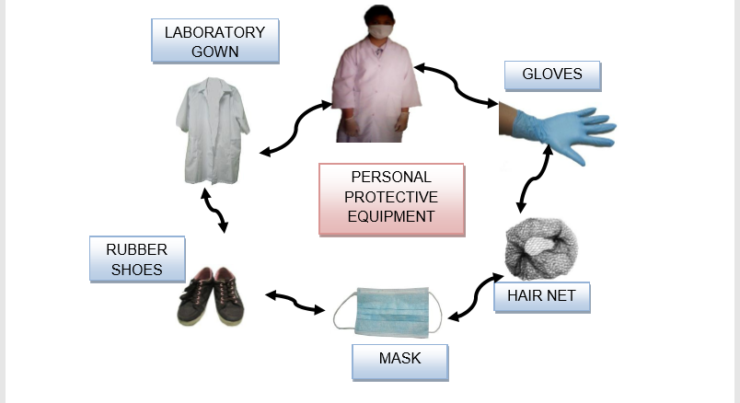

(PPE)

Photo credits to Delantar, Z.et al taken from OSF Food Processing Laboratory

1. **PRACTICING OCCUPATIONAL HEALTH AND SAFETY DURING OPERATION OF EQUIPMENT**

To check the tools and equipment before using you should do the following:

* Before operating an unfamiliar pieces of equipment, study the manufacturers’ operating manual, or consult with someone who is familiar with the piece of equipment and has operated it recently.
* Learn how to determine when a piece of equipment is not operating correctly. When equipment malfunctions, shut it down immediately, identify the equipment as being defective, and report the malfunction to a supervisor.
* Keep the equipment clean. If disassembly of the equipment is possible, consult the manufacturers operating manual. If an operating manual is not available, consult with someone who has cleaned the equipment in the recent past.
* Conserve energy by knowing the preheating time required by cooking equipment and by planning the [production of food.
* Know when it is more efficient to use manual than to use equipment.

***Note:*** *As a general rule, never use a piece of equipment until you are thoroughly familiar with its operation and features.*

**Let us Remember!**

The best source of information about how to use a piece of equipment, as well as its safety features and how to clean it, it is the owner’s manual and the operating instruction from the manufacturer of the equipment.

3

**Other occupational health and safety during operation of equipment**

* + 1. **Installation of equipment should be in areas where cleaning and servicing will be safe and easy**
* Food-contact surfaces of equipment should be constructed of suitable materials, free of cracks, crevices, rust and drips of paint
* Lubricants used in can sealers and vacuum packer must be of good quality; bearing or gears which are not directly in contact with food during processing may use the prescribed lubricant and oil
  + 1. **Equipment should be designed to allow adequate cleaning**
* It should be made of materials that can be easily cleaned
  + 1. **Equipment should be well- selected and efficiently placed to minimize transporting**
* It should be designed to achieve the required food temperature, and should be easily monitored and controlled
  + 1. **All tools and devices that require calibration must routinely be calibrated and a record of all calibrations must be maintained**
* Properly place levers hand wheels so operator can manipulate them with the least change of position.
  + 1. **Identify and keep records of all equipment with regards to their serviceability; if repairable and defective.**
* To protect against electrical hazards, do not immerse lid or any part of the machine cord or plug in the water.
  + 1. **Read the manufacturers’ specifications carefully for accurate and safe manipulation/operation of equipment or machine.**
* Do not touch hot surfaces. Allow to cool before putting on or taking off parts.

The Food and Drug Administration (FDA) and construction standards from National Sanitation Foundation (NSF) International and Underwriters Laboratories Inc. require food equipment and utensils to be:

1. smooth;
2. seamless;
3. easily cleaned
4. easy to take apart, disassemble;
5. easy to put together or reassemble; and,
6. equipped with rounded corners and edges.

4

|  |  |
| --- | --- |
| C:\Users\DEPED\Desktop\ADM specs\ADM cover and icons\ADM Icons\whats more.jpg | ***What’s More*** |

Directions: Modified TRUE or FALSE. Write TRUE if the statement

Is correct. Change the underline words if it is false.

|  |  |
| --- | --- |
| _____1. | When equipment malfunctioning just continue the operation. |
| _____2. | Conserve energy by knowing the post heating time required by cooking equipment. |
| _____3. | Before operating an unfamiliar equipment, study the manufacturers’ operating manual. |
| _____4. | To protect equipment against electrical hazards, immerse lid or any part of the machine or plug in the water. |
| _____5. | Hot surfaces should not be touch. Allow to cool before putting or taking off parts. |

|  |  |
| --- | --- |
| C:\Users\DEPED\Desktop\ADM specs\ADM cover and icons\ADM Icons\Isaisip.jpg | ***What I Have Learned*** |

Directions: Matching Type. Match equipment column A with

their functions column B.

|  |  |
| --- | --- |
| _____1. Hairnet | * 1. Reduces the risk of contamination from hands |
| _____2. Face mask | * 1. Helps avoid slippage |
| _____3. Apron | * 1. Helps maintain cleanliness |
| _____4. Glove | * 1. Prevents hair from falling into the food products |
| _____5. Rubber shoes | * 1. Serve as a barrier t airborne contamination of food during sneezing, coughing and talking. |



***What I Can Do***

Directions:

1. Look for video clip from any form of media showing a food processing laboratory who failed to practice Occupational Health and Safety Procedures.
2. List down your observation in the processing laboratory and its personnel including your suggestion for the improvements of the laboratory operations.
3. Submit your output to your teacher.

5

|  |  |
| --- | --- |
| C:\Users\DEPED\Desktop\ADM specs\ADM cover and icons\ADM Icons\Tayahin.jpg | ***Assessment*** |

**POST -ASSESSMENT**

Direction: Select the best answer from the give choices below. Write only

the letter of your answer in your notebook.

1. What PPE helps avoid slippage?
   * + 1. wedge
       2. sandals
       3. slippers
       4. rubber shoes
2. Why is food processing individual obliged to wear PPE?
3. to make them more attractive
4. to reduce the risk of contamination
5. to accomplish the task easily
6. to make them more energetic
7. Why should you check equipment that is electrically operated before using them?
8. to prevent accidents.
9. to practice using the equipment.
10. to avoid errors during operation.
11. to make sure plugs, outlets and electrical insulation are not defective.
12. Which is not included in checking the tools and equipment before using?
    * + 1. study the manufacturers’ manual
        2. keep the equipment clear
        3. never use the equipment
        4. learn how to determine when equipment I not operating correctly
13. Which of the following PPE serve as a barrier to airborne contamination of food during sneezing, coughing and talking?
14. hairnet
15. apron
16. mask
17. gloves

6

|  |  |
| --- | --- |
| Lesson2 | Following Manufacturers’ Specification |



***What I Need to Know***

At the end of this lesson, you are expected to:

1. operate machine/ equipment in a safe and controlled manner in accordance to manufacturers’ specification.



***What I Know***

Directions: Write only the letter of your answer in your notebook.

1. Why should you operate or use equipment in accordance to the manufacturer ‘s specifications?
   1. to correctly operate them
   2. to determine cost of equipment
   3. to be familiar with the necessary safety precautions
   4. to be familiar with their parts and functions
2. Why is it important to interpret correctly the manufacturers specifications of equipment before operating them in order to?
   1. know where to return them
   2. be familiar with their parts and their function
   3. avoid accidents due to faulty operation of equipment
   4. be able to determine the correct operation of the equipment
3. Your teacher instructed you to check and inspect all the food processing equipment in your laboratory room. Which of the following will you do after the inspection?
   1. Make an oral report.
   2. Store the food processing equipment.
   3. Make a checklist of the tools and equipment inspected.
   4. Prepare a written report following the standard format.
4. Which of the following is not a warning labels specify how to handle and position the equipment?

|  |  |
| --- | --- |
|  |  |
|  |  |
|  |  |
|  |  |

1. Which of the following does not belong to the manufacturers’ manual specifications?
2. Repair and warranty
3. Price list
4. Precautions
5. Specifications

7



***What’s In*?**

Explain in 3-5 sentences why is it necessary not to use a piece of equipment unless you are its operation and features?

|  |  |
| --- | --- |
| C:\Users\DEPED\Desktop\ADM specs\ADM cover and icons\ADM Icons\Tuklasin.jpg | ***What’s New?*** |

From the word in the box, pick out the information found inside

the manufacturers’ manual specifications.

|  |  |
| --- | --- |
| * Sticker | * Receipt dimension |
| * Warning label | * Materials |
| * Description price | * Instructions delivery fee |

|  |  |
| --- | --- |
| C:\Users\DEPED\Desktop\ADM specs\ADM cover and icons\ADM Icons\suriin.jpg | ***What is It?*** |

**FOLLOWING MANUFACTURER’S SPECIFICATIONS**

Food processing equipment when sold are provided with a manual containing the manufacturer ‘s specifications and a necessary reminder to the processor in the form of a sticker or warning label is attached to the equipment itself. This is an assurance that the equipment/machine or tool is in excellent condition for it has passed quality control standards in its construction. The specification usually gives a detailed description of the equipment - dimensions, materials, and other relevant information regarding the equipment or machine.

The dimension is the size of an object in terms of length, width, or height of the equipment/machine or tool.

The capacity specifies the amount which a device can hold or contain as in boilers, cookers, or steamers or a weighing scale. The manufacturer ‘s specifications are usually contained in the manual which accompanies the equipment. The food processor must thoroughly read and understand all the information contained in the manual, especially if the equipment is to be operated electrically. Aside from knowing the correct operation of the equipment, it is also important to know the following:

8

1. Basic safety precautions when using the equipment 2. Warning labels which specify how to properly operate the equipment 3. Instructions on the proper care of the equipment/machine 4. Instructions on the correct operation of the equipment

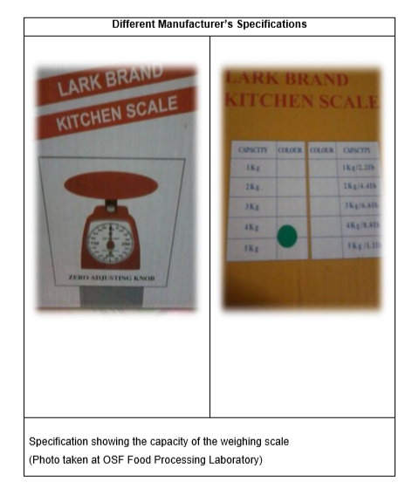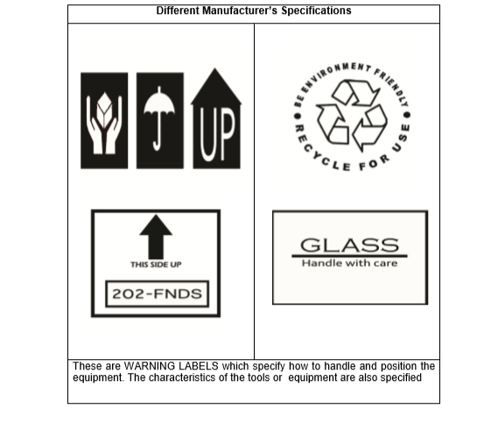The manufacturer ‘s specifications must be understood by the food processor so that the food processing equipment can be operated properly. Below are some photos of manufacturer ‘s specifications, which must be properly interpreted resulting to an accurate and safe operation/manipulation of an equipment/machine:

9

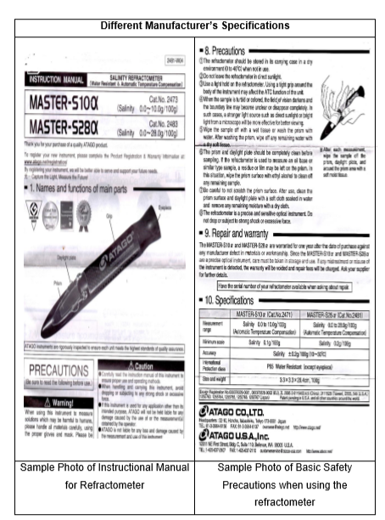

10

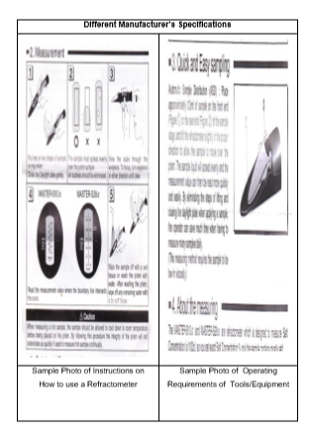

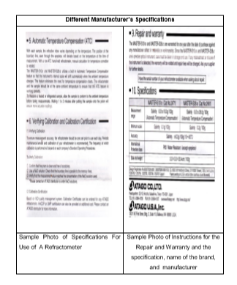

11

|  |  |
| --- | --- |
| C:\Users\DEPED\Desktop\ADM specs\ADM cover and icons\ADM Icons\whats more.jpg | ***What’s More*** |

Direction: Match column A with column B. Write answers in

your notebook.

|  |  |
| --- | --- |
| A | B |
| _____1. Dimension | * 1. usually contains in the manual which accompanies the equipment |
| _____2. Capacity | * 1. contains the necessary information about the equipment tool |
| _____3. Manufacturers’ specification | * 1. it is the size in terms of length, width or height of the equipment |
| _____4. Warranty label | * 1. specifies how to operate properly the equipment |
| _____5. Manual | * 1. specify the amount which a device can hold or contain |



|  |  |
| --- | --- |
|  | ***What I Have Learned*** |

Directions: Provide word or phrase to make the statements complete.

Use activity notebook

* + 1. It is important to interpret correctly the manufacturers’ specifications of equipment before operating them in order to _____.
    2. You are instructed by your teacher to check and inspect all the food processing equipment in your laboratory now so that you can _____.
    3. Warning labels specify how to _____.
    4. One of the instructions that you should know is the _____.
    5. You should operate or use equipment in accordance to the manufacturers’ specifications in order to _____



***What I Can Do***

Directions: Give the interpretation of each symbol.

|  |  |
| --- | --- |
|  |  |
|  |  |
|  |  |
|  |  |
|  | - |

12

|  |  |
| --- | --- |
| C:\Users\DEPED\Desktop\ADM specs\ADM cover and icons\ADM Icons\Tayahin.jpg | ***Assessment*** |

**POST -ASSESSMENT**

Direction: Select the best answer from the given choices below. Write only

the letter of your answer in your notebook.

1. Your teacher instructed you to check and inspect all the food processing equipment in your laboratory room. Which of the following will you do after the inspection?
2. Make an oral report.
3. Store the food processing equipment.
4. Make a checklist of the tools and equipment inspected.
5. Prepare a written report following the standard format.
6. Which of the following is not a warning labels that specifies how to handle and position the equipment?

|  |  |
| --- | --- |
|  |  |
|  |  |
|  |  |
|  |  |

1. Why should you operate or use equipment in accordance to the manufacturer ‘s specifications?
2. to correctly operate them
3. to determine cost of equipment
4. to be familiar with the necessary safety precautions
5. to be familiar with their parts and functions
6. Which of the following does not belong to the manufacturers’ manual specifications?
7. Repair and warranty
8. Price list
9. Precautions
10. Specifications
11. Why is it important to interpret correctly the manufacturers specifications of equipment before operating them in order to?
12. know where to return them
13. be familiar with their parts and their function
14. avoid accidents due to faulty operation of equipment
15. be able to determine the correct operation of the equipment

13

|  |  |
| --- | --- |
| Lesson3 | Operate Specific Equipment or Machine |



***What I Need to Know***

At the end of this lesson, you are expected to:

* + - * 1. operate machine/ equipment in a sage and controlled manner in accordance with OHS requirements.

|  |  |
| --- | --- |
|  | ***What I Know*** |



Directions: Write only the letter of your answer in your notebook.

1. How many cups of water should be poured to the pressure cooker before placing the rack and the packed jars?
2. ½ cups
3. 2 ½ cups
4. 3 ½ cups
5. 4 ½ cups
6. What pressure gauge is observed in turning off the stove?
7. Zero (0)
8. One
9. Two
10. Three
11. Which of the following is not used to fasten the can sealer firmly to a table or chain?
12. Clamp
13. Screw
14. Thumbtacks
15. Nails
16. What direction should the can lifter handle e turned to lower the base plate of the can sealer?
17. To the center
18. To the middle
19. To the right
20. To the left
21. What is the best temperature that he jars and can cooker be cooled?
22. Room temperature
23. Low temperature
24. High temperature
25. Air temperature

14



***What’s In*?**

Why is manual provided in sealing food processing equipment?

|  |  |
| --- | --- |
| C:\Users\DEPED\Desktop\ADM specs\ADM cover and icons\ADM Icons\Tuklasin.jpg | ***What’s New*** |

Directions: Classify the following accessories to which equipment they are part of.

Write down answers on your activity notebook following the box below.

|  |  |
| --- | --- |
| Pressure regulator | Gasket |
| Base plate | Seaming chuck |
| Hole nut | Thumb screw |
| Safety valve | Stem vent |
| Steaming roller washer | Screwed in handles |

|  |  |
| --- | --- |
| Pressure cooker accessories | Can sealer accessories |
|  |  |
|  |  |
|  |  |
|  |  |
|  |  |

|  |  |
| --- | --- |
| C:\Users\DEPED\Desktop\ADM specs\ADM cover and icons\ADM Icons\suriin.jpg | ***What is It*** |

* + 1. **Pressure Cooker**

15

|  |
| --- |
| Functions of the Pressure Cooker   1. Reduce cooking time by as much as 70% which is great reduction in time of foods normally stay on the store boiling or steaming away the natural taste and the nutrients. Overall pressure cooker enhances the richness and natural flavors of foods. 2. Other Pressure Cooker accessories  * Pressure regulator * Stem vent * Screwed on handles * Sealing rings or gaskets * Lid * See the source imageSafety valve |

**Operating Pressure Cooker**

* + 1. Pour 2 1/2 cups of water, place the rack then place the packed jars

in the cooker

* + 1. Place the cover of cooker. The arrow on the cover should be aligned

with the line mark at the body

* + 1. Tighten two opposite knobs evenly at the same time
    2. Turn on the stove and place the cooker on the burner. Place petcock

in horizontal position. Wait until a steam comes out from the

petcock for a total of 7-10 minutes then close the petcock.

* + 1. Wait until the pressure gauge registers the desired pressure
    2. If desired pressure is reached, count the processing time. Maintain

the pressure until the end of the prescribed processing time

* + 1. Turn off the stove. Wait until the pressure gauge registers zero

(0) pressure

* + 1. Loosen two opposite knobs at the same time. Open the cover in

slanting position away from the face

* + 1. Remove the glass jars one at a time from the cooker and close the

jars. Cool the jars and cooker at room temperature

16

**ILLUSTRATION ON THE HOW TO OPERATE A PRESSURE COOKER** *(Photos taken at Bukidnon National School of Home Industries Food Processing Laboratory)*

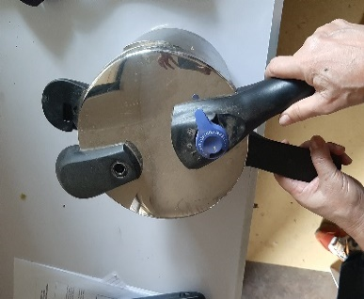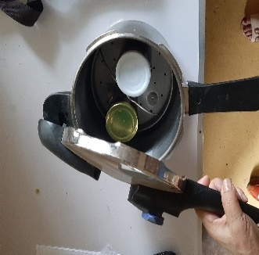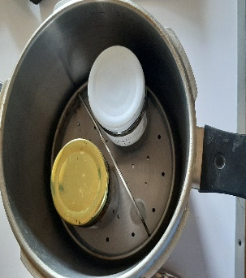

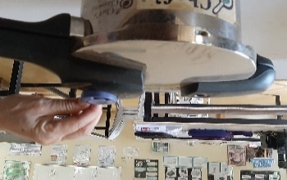

* + 1. [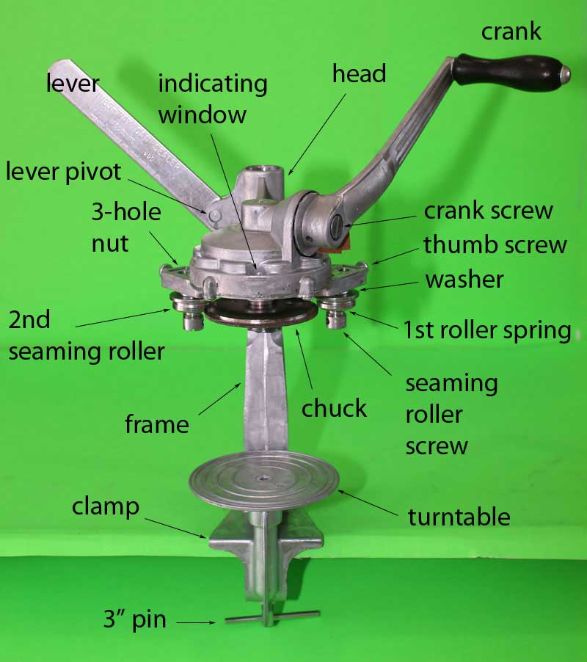](https://www.google.com.ph/url?sa=i&url=https://www.meatsandsausages.com/canning-equipment/can-sealer/ives-way/parts-list&psig=AOvVaw0OV0_NYv8x1BHHtxOTDD8B&ust=1595838446713000&source=images&cd=vfe&ved=0CAIQjRxqFwoTCNiw4d2_6uoCFQAAAAAdAAAAABAK)**Can Sealer**

|  |
| --- |
| Can sealer or Seamer machine have a:   1. Base plate (turntable)- provides support for the can body 2. Seaming chuck- smugly holds the top of the can (lid) and ails as a support surface for the pressure cooker 3. A set of operation roller- the first roller interlocks the lid with the body in the can.   Other Can Sealer Accessories:   * 3-hole nut * Thumb screw * Seaming roller screw * Seaming roller washer |

17

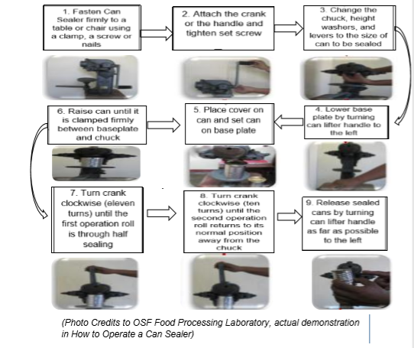**Operating Can Sealer**

|  |  |
| --- | --- |
| C:\Users\DEPED\Desktop\ADM specs\ADM cover and icons\ADM Icons\whats more.jpg | ***What’s More?*** |

Directions: Label the following part of each picture shown below.

1. [](https://www.google.com.ph/url?sa=i&url=https://www.meatsandsausages.com/canning-equipment/can-sealer/ives-way/parts-list&psig=AOvVaw3PEFk2BUirt0W0T-hai2ru&ust=1595838436358000&source=images&cd=vfe&ved=0CAIQjRxqFwoTCMDkye6_6uoCFQAAAAAdAAAAABAs)Can Sealer

5

4

3

2

1.

18

1. 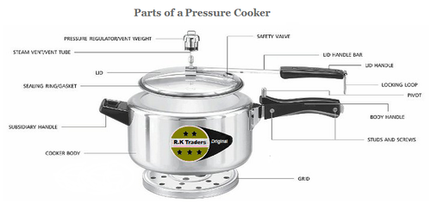Pressure Cooker

5

4

3

2

1

1

|  |  |
| --- | --- |
| C:\Users\DEPED\Desktop\ADM specs\ADM cover and icons\ADM Icons\Isaisip.jpg | ***What I Have Learned*** |

Directions:

1. In your notebook arrange the following steps in operating can sealer by writing the number corresponding to each statement.

_____ Lower base plate by turning can lifter handle to the left.

_____ Raised can until it is clamped firmly between baseplate and chuck.

_____ Turn crank clockwise until the second operation roll returns to its normal

position away.

_____ Release sealed cans by turning can lifter handle to the left.

_____ Fasten can sealer firmly to a table on chair using a clamp.

_____ Turn crank clockwise until the first operation roll is through half sealing.

_____ Attach the crank in the handle and tighter set screw.

_____ Change the chuck, height washers and levers to the size of can to be sealed.

_____ Place cover on can and set can on baseplate.

1. Give the benefits of a pressure cooker.

19

|  |  |
| --- | --- |
| C:\Users\DEPED\Desktop\ADM specs\ADM cover and icons\ADM Icons\Isagawa.jpg | ***What I Can Do*** |

Direction: Make a video presentation on actual operation of a pressure cooker.

Send your output to our group hat for checking.

|  |  |
| --- | --- |
| C:\Users\DEPED\Desktop\ADM specs\ADM cover and icons\ADM Icons\Tayahin.jpg | ***Assessment*** |

**POST -ASSESSMENT**

Direction: Select the best answer from the given choices below. Write

only the letter of your answer in your notebook.

* + 1. What is the best temperature that the jars and can cooker be cooled?
       1. Room temperature
       2. Low temperature
       3. High temperature
       4. Air temperature

1. In turning off the stove, wait until the pressure gauge registers at _____ pressure.
   * + 1. Zero (0)
       2. One
       3. Two
       4. Three
2. How many cups of water should be poured to the pressure cooker before placing the rack and the packed jars?
   * + 1. ½ cups
       2. 2 ½ cups
       3. 3 ½ cups
       4. 4 ½ cups
3. Which of the following is not used to fasten the can sealer firmly to a table or chain?
   * + 1. Clamp
       2. Screw
       3. Thumbtacks
       4. Nails
4. What direction should the can lifter handle be turned to lower the base plate of the can sealer?
   * + 1. To the center
       2. To the middle
       3. To the right
       4. To the left

20

10

Technology and Livelihood Education

(FOOD PROCESSING)

**Quarter 2 – Module 2**

**Maintaining Equipment and Resources**

Department of Education. Republic of the Philippines

|  |  |
| --- | --- |
| Lesson4 | Shut down, Maintain and Clean Equipment Machines according to Workplace Procedure |



***What I Need to Know***

At the end of this lesson, you are expected to:

1. shut down equipment/ machine according to workplace procedure and manufacturers’ specification.
2. clean and maintain the work over tools and machines in accordance with workplace requirements and manufacturers’ specification.



***What I Know***

Directions: Write only the letter of your answer in your notebook.

1. Which of the following is not a reason of inspecting and checking equipment/ machine before, during and after using them?
   1. to determine defective machine parts
   2. to make sure they are in good condition
   3. to avoid errors and accidents during operation
   4. to serve as guide in storing the equipment/machine
2. Which of the following implies that equipment is in its shut down period?
   1. the light blinks
   2. control is in Off position.
   3. the plate or another part is hot
   4. there is noise from the machine
3. Which of the following is not a regular maintenance procedure?
   1. checking defects of machines
   2. checking all parts are present
   3. shutting down and turning on of equipment
   4. checking the switch, plugs and electrical cords
4. Your teacher assigned you to check machine parts which easily corrode or wear out due to rubbing surfaces. Which of these will you do as preventive maintenance?
   1. replaces the parts
   2. wash and wipe dry
   3. apply lubricant, oil or grease
   4. removes the rust with sand paper
5. Why do we clean and sanitize equipment?
   1. to replace the equipment
   2. to check the missing parts
   3. to see if they are in good condition
   4. to remove dirt and food material that harbor microorganism

22



***What’s In*?**

Directions: Summarize the steps in Operating Can Sealer

and Pressure Cooker.

|  |  |
| --- | --- |
| C:\Users\DEPED\Desktop\ADM specs\ADM cover and icons\ADM Icons\Tuklasin.jpg | ***What’s New*** |

Direction: Answer this based on your own knowledge.

* + 1. How are the following equipment/ machines be shut down?
       1. Food Processor/Blender
       2. Refrigerator/ Freezer
       3. Gas Range/ Electric Stove
    2. What do you mean by LOTO in food processing?

|  |  |
| --- | --- |
| **C:\Users\DEPED\Desktop\ADM specs\ADM cover and icons\ADM Icons\suriin.jpg** | ***What is It*** |

1. **Shutting Down Equipment/Machine**

An equipment shutdown involves ensuring controls are in the OFF position and verifying that all moving parts, the sealing plates in a vacuum pack machine for example, have come to a complete stop. Food processing equipment/tools which are electrically operated like Food Processors, Electronic Weighing Scale, Electric Meat Grinder, Electric Mixers have a Manual of Instructions for proper shutdown.

1. **Locate Emergency Stop Functions on Equipment**

Every Manual of Instructions provided with the equipment /machine, it features notes on the location of emergency stop function of the equipment.

23

|  |  |
| --- | --- |
| Equipment/ Machine/ Device | Emergency Stop Functions |
| 1. Convection Oven | It has an automatic safety shut-off handle which automatically shuts off when the handle on the lid is raised to an upright position. |
| 2. Food Processor/ Blender | It has an OFF and ON button that can be pressed to operate the equipment |
| 3. Refrigerator/Freezer | The temperature controller also serves to turn in on and off |
| 4. Vacuum Pack Machine | It has an OFF and ON button that can be pressed to operate the equipment |
| 5. Gas Range/ Electric Stove | It has a control panel for switching the device ON and OFF |

1. **Routine Maintenance Procedures**

Regular maintenance activities should be in conformity with the manufacturer ‘s specification. Below is the usual maintenance procedure done with equipment/machines:

* Tighten all electrical connections. Check the switch, plugs and cords of electrically-powered equipment
* Check the parts of machines /equipment to determine if there are defects, wear and tear, cracks, leaks, rust or corrosion
* Check if all parts are still present. Missing parts will cause the equipment or machine to malfunction
* Clean, sanitize and store equipment according to manufacturer ‘s specifications
* Check the condition of equipment if they are serviceable, repairable or defective
* Apply lubricants/oil to parts that undergo corrosion and experience friction

**D. Cleaning and Sanitation Procedures for Work Areas and Equipment**

**Ways of cleaning up equipment/machines/utensils:**

24

|  |  |
| --- | --- |
| Equipment/ Machine/ Devices | HOW TO CLEAN |
| 1. Pressure Cooker | Wash thoroughly with soap and hot, clean water then drain completely before and after use. Clean the petcock by carefully inserting a thin piece of wire and run it gently in and out to be sure it is cleared and unobstructed. Rinse with hot water. Wipe off the metal to metal seal with a clean towel to remove any build- up or hardened lubricant. |
| 2. Food Processor/ Blender | Clean with sponge or plastic scrubber. Rinse , wipe and dry. |
| 3. Refrigerator/ Freezer | Defrost regularly. Clean detachable parts and wash in warm water and baking soda solution (use 1 tablespoon of soda per liter of water). Follow the same procedure for cleaning the door gaskets, wire baskets, and plastic parts. Wipe spilled food immediately. Wash inside shelves and trays at least twice a week. Rinse and dry thoroughly. |
| 4. Vacuum Pack Machine | Remove all sediment and wipe grease from top and plate of the sealer. Wipe with a damp cloth then a dry cloth. |
| 5. Gas Range/ Electric Stove | Remove all burnt sediment and wipe grease from top of stove after use; scrape grease from cracks, openings and hinges; when cool, wash top of stove; scrub burners with warm water and scouring pads; clean the holes with a hair pin or wire. Rinse with clean, hot water and dry the rack. Turn the burners upside down. |
| 6. Refractometer | After each measurement, wipe the sample off the prism, daylight plate and around the prism area with soft , dry moist tissue. |
| 7. Cooking utensils | Drain off fat, juice, sauces and strain out sediment; fill with water and detergent; rinse, and dip in sanitizing solution then dry; wipe with damp cloth. |
| 8. Cutting tools | Drain off fat, juice, sauces and strain out sediment; fill with water and detergent; rinse, and dip in sanitizing solution then dry; wipe with damp cloth. |

**Surfaces and Cleaning Summary**

Surface composition influences the effectiveness of different cleaning and sanitizing chemicals/agents.

25

|  |  |
| --- | --- |
| Surface Composition | How to Clean |
| 1. Stainless Steel | Use non-abrasive acidic and alkaline cleaners; do not use hydrochloric acid or chlorides; corrosive properties vary with grade. |
| 2. Plastic | More corrosion resistant than stainless steel; resistant to chlorine; may crack or cloud from prolonged exposure to strong acidic or alkaline cleaner. |
| 3. Nylon | Do not use acidic cleaners. |
| 4. Rubber | Deteriorates with constant use of chlorine; use alkaline cleaners. |
| 5. Brass, copper, mild steel | All less corrosion- resistant than stainless steel; acidic cleaners encourage steel rusting; use moderately alkaline cleaners with corrosion inhibitors. |
| 6. Aluminum | Readily attacked by acidic and highly alkaline cleaners, use only soft, metal - safe and moderately alkaline cleaners. |
| 7. Wood | Should not be used in food application; where used, clean with detergents containing surfactants. |
| 8. Iron Drains | Acidic cleaners are corrosive; use moderately alkaline cleaners. |
| 9. Painted surfaces | Use moderately alkaline cleaners. |
| 10. Concrete | Use alkaline cleaners. |

**E. Lockout and Tag- out Procedures**

* 1. What is Lockout Tag - Out (LOTO)?

Lock out is the placement of a lock or tag on an energy – isolating device indicating it is not to be operated until removal of the lock or tag in accordance with the established procedure. It physically locks the system in safe mode.

Tag- out is a labelling process that involves attaching or using an indicator that includes the following indicator:

* Why the lockout / tag -out is required
* Time of application of the lock/tag
* The name of the person who attached the tag and locked the system

1. Purpose of Lock Out /Tag Out

* Protect contact with a hazard while performing a task that requires the removal, by – passing, de activation of safeguarding devices
* Prevent the unintended release of hazardous energy
* Prevent the unintended start-up or motion of machinery, equipment, processes

1. Basic Steps of Locking and Tagging out Food Processing Equipment

* Prepare for shut down of the equipment/machine
* Notify all affected persons. Inform what is going to be locked/tagged out; why it is going to be locked/tagged out; for approximately how long the equipment/machine will be unavailable; the person responsible for the lock out/ tag out; who to contact for more information
* Equipment/machine should be shut down in normal manner; ensuring controls are in the OFF position.
* Isolate equipment/machine from Hazardous Energy through written instructions ex. Electrical Energy Lockout – switch electrical disconnects to the Off position

26

* Most electrical equipment has capacitors. Residual or stored energy must be discharged during lockout process.
* During lock out/ tag out, there should be one key for each lock which can be removed by those who installed them
* Verify that the system is properly locked before beginning any work
* Perform maintenance activity
* Remove Lock Out/ Tag Out

To remove locks and tags from a system that is now ready to be

put back into service, the following general procedure can be used:

* Inspect the work area to ensure all tools and items have been removed from the hazardous area.
* Confirm that all persons are safely located away from the hazardous area
* Verify that controls are in neutral position
* Remove devices and re-energize the machine
* Notify affected persons that servicing is completed

|  |  |
| --- | --- |
| C:\Users\DEPED\Desktop\ADM specs\ADM cover and icons\ADM Icons\whats more.jpg | ***What’s More*** |

Direction:

1. Enumerate at least 5 electrically operated equipment/ tools.
2. Matching Type: Match column A with B.

|  |  |
| --- | --- |
| A | B |
| _____1. Gas range/  Electric stove | * 1. has an automatic safety shut off handle. |
| _____2. Convection Oven | * 1. has temperature controller which serves to turn in on or off. |
| _____3. Vacuum Pack | * 1. has an off and on button that can be pressed. |
| _____4. Food Processor  / Blender | * 1. has a control panel for switching the device on and off. |
| _____5. Refrigerator  / Freezer |  |

27

|  |  |
| --- | --- |
| C:\Users\DEPED\Desktop\ADM specs\ADM cover and icons\ADM Icons\Isaisip.jpg | ***What I Have Learned*** |

|  |
| --- |
| Direction: The following are the basic steps of locking and tagging  out food processing equipment. Arrange them chronologically. |

|  |  |
| --- | --- |
| _____ | During lock out/ tag out, there should be one key for each lock which can be removed by those who installed them |
| _____ | Remove Lock Out/ Tag Out |
| _____ | Prepare for shut down of the equipment/machine |
| _____ | Equipment/machine should be shut down in normal manner; ensuring controls are in the OFF position. |
| _____ | Perform maintenance activity |
| _____ | Notify all affected persons. Inform what is going to be locked/tagged out; why it is going to be locked/tagged out; for approximately how long the equipment/machine will be unavailable; the person responsible for the lock out/ tag out; who to contact for more information |
| _____ | Verify that the system is properly locked before beginning any work |
| _____ | Most electrical equipment has capacitors. Residual or stored energy must be discharged during lockout process. |
| _____ | Most electrical equipment has capacitors. Residual or stored energy must be discharged during lockout process. |

|  |  |
| --- | --- |
| C:\Users\DEPED\Desktop\ADM specs\ADM cover and icons\ADM Icons\Isagawa.jpg | ***What I Can Do*** |

Directions: Select at least two among the given equipment and demonstrate how to shutdown. Submit your output through video presentation.

|  |  |
| --- | --- |
| 1.) Electric Stove | 5.) Electric Meat Grinder |
| 2.) Electric Mixers |  |
| 3.) Hair Blower |  |
| 4.) Refrigerator  28 |  |
| C:\Users\DEPED\Desktop\ADM specs\ADM cover and icons\ADM Icons\Tayahin.jpg ***Assessment*** |  |

**POST -ASSESSMENT**

Direction: Write only the letter of your answer in your notebook.

* 1. Why do we clean and sanitize equipment?

1. to replace the equipment
2. to check the missing parts
3. to see if they are in good condition
4. to remove dirt and food material that harbor microorganism
   1. Which of the following is not a regular maintenance procedure?
5. checking defects of machines
6. checking all parts are present
7. shutting down and turning on of equipment
8. checking the switch, plugs and electrical cords
   1. Which of the following is not a regular maintenance procedure?
9. checking defects of machines
10. checking all parts are present
11. shutting down and turning on of equipment
12. checking the switch, plugs and electrical cords
13. Your teacher assigned you to check machine parts which easily corrode or wear out due to rubbing surfaces. Which of these will you do as preventive maintenance?
14. replaces the parts
15. wash and wipe dry
16. apply lubricant, oil or grease
17. removes the rust with sand paper
18. Your teacher assigned you to check machine parts which easily corrode or wear out due to rubbing surfaces. Which of these will you do as preventive maintenance?
19. replaces the parts
20. wash and wipe dry
21. apply lubricant, oil or grease
22. removes the rust with sand paper

29

|  |  |
| --- | --- |
| Lesson5 | Safe Workplace and Emergency Procedures |



***What I Need to Know***

At the end of this lesson, you are expected to:

1. identify relevant legislative provisions including occupational health and safety requirements
2. explain the importance of a safety workplace
3. apply emergency procedure in case of emergency

|  |  |
| --- | --- |
|  | ***What I Know*** |



Direction: Write only the letter of your answer in your notebook.

* 1. What Republic Act is known as national solid waste management act?
     1. RA 3009
     2. RA 3090
     3. RA 9003
     4. RA 9030
  2. What device designed to be worn or held by an individual for protection against hazard?
     1. Personal Protective Equipment
     2. Solid Waste Management
     3. Emergency Procedure
     4. Health and Safety Requirements
  3. Which of the following Republic Act strengthen the food safety regulatory system?
     1. RA 9003
     2. RA 8976
     3. RA 8172
     4. RA 10661
  4. Which of the following is NOT a major concern of personnel hygiene?
     1. Must wear suitable PPE
     2. Health status of the person
     3. Marital status of the person
     4. Free from any disease
  5. What is the meaning of ABC in the procedure of first aid?
     1. Airline, breathing and circulation
     2. Airway, breathing and circulation
     3. Airway, branding and circulation
     4. Airway, breathing and communication

30



***What’s In*?**

Direction: Differentiate Log- Out from Tag- Out and give its purpose.

|  |  |
| --- | --- |
| C:\Users\DEPED\Desktop\ADM specs\ADM cover and icons\ADM Icons\Tuklasin.jpg | ***What’s New*** |

Direction: Arrange the jumbled letter to form a correct word that is found

in this lesson.

* 1. w e o c r a k l p
  2. y e m e n g c r e
  3. k l a e g a e
  4. a m d e a d g
  5. t l e l g e I v I s a

|  |  |
| --- | --- |
| C:\Users\DEPED\Desktop\ADM specs\ADM cover and icons\ADM Icons\suriin.jpg | ***What is It*** |

1. **Safe Workplace Procedures Good Manufacturing**

Requirements/Regulations should be adhered to in order to have an ideal workplace for Food Processing. The following should be observed:

* 1. **Personnel Hygiene** – the major concern here is being healthy. This includes the health status of the person – free from any disease, illness, and injury. Processors should maintain a high degree of personal cleanliness; must wear suitable protective clothing, hairnet, gloves, facial mask, and rubber shoes;
  2. **Food processing plants/establishments** should preferably be located in areas which are free from objectionable odors, smoke, dust or other contaminants and are not subject to flooding.

a. Maintain the cleanliness of the grounds around the food plant

b. Maintain sanitary plant construction and design with regards to

the following:

* Floors, ceiling, walls, ventilation
* Plant lighting
* Water supply
* Drainage.
* Waste management

31

* Toilet
* Washing facilities
* Installation of equipment

1. **Emergency Procedures   
   1. An emergency procedure is a plan of action** to be used in the event of an emergency, for instance, a fire. Common emergency procedures:

* Leave the building immediately by the nearest exit.
* Dial emergency services. (The number is dependent upon location)

Observe recovery position to be used when a person is unconscious.

* Apply First Aid. This is the provision of initial care for an illness or injury. It is usually performed by a lay person to a sick or injured patient until medical treatment can be accessed. The ABC ‘s of First Aid, which focus on critical life-saving intervention, must be rendered before treatment of less serious injuries. ABC stand for airway, breathing and circulation. 3B ‗s stands for breathing, bleeding and bones.

**Points to be remember for the Preservation of Life:**

To remember the procedures of first aid, use ABC which stands for **Airway, Breathing and Circulation**. Details are as follows:

* All persons need an open airway – a clear passage where air can move in through the mouth or nose without obstruction
* If an unconscious patient is lying on his or her back, the tongue may fall backward obstructing the airway. Tip the head backward, which mechanically lifts the tongue clear.

If the patient is choking, you will be taught to deal with this through a combination of back slaps and abdominal thrusts.

* If the patient is not breathing, you need to undertake what is probably the most recognized first aid procedure- cardiopulmonary resuscitation (CPR) or look for someone who is trained to do this.

**2. Common Emergencies during Food Processing**

**a. Gas Leakage WITHOUT Fire (From Petronas Energy Philippines)**

* Extinguish all sources of ignition within the area. Do not switch ON or OFF electrical switches as they might create sparks.
* Close the valve to stop the gas flow.
* Apply a soapy water solution on the tank and pipe fittings to trace the source of leak.
* Disperse the LPG vapor by using water to induce air movement. Spray the water directly and slowly towards the vapor cloudy surface.
* Keep persons out of vapor cloud.

1. **In Case of Leakage WITH Fire**

* If escaping gas is on fire, attempt to extinguish it by closing the valve to stop the leak. If the valve which can stop the gas flow is involved in the fire, consider the possibility of effecting shut-off by protecting the firemen while they are closing the valve. This action must be undertaken only by trained personnel.
* If the leakage cannot be stopped, allow the fire to burn out. However, the fire must be kept under control by spraying sufficient volume of cooling water on the upper portion of the tank to reduce pressure inside and slow down the leakage. Failure of the tank will occur if the metal surface becomes overheated.

32

* If a fire occurs near the LPG cylinder, spray water on the upper portion of the cylinder to keep the metal surfaces cool. c. In case of FIRE
* When an LPG cylinder is exposed to excessive heat, the container should be kept as cool as possible by applying a spray of water on it.
* If vapor from the valve has ignited at the scene of a blaze, water should be applied on the cylinder to lower the temperature and decrease the inside pressure so that valve will close and the fire will extinguish itself.

1. **Reporting Faulty or Damaged Machine/Equipment**

Reporting on faulty or damaged equipment is necessary in Food Processing. This will facilitate trouble - shooting and procurement of parts for replacement or the repair of defective parts.

**D. Managing Waste (Reduce, Re-use, and Recycle 3Rs)**

**1. Legal Basis of Waste Management Republic Act No. 9003, known as the National Solid Waste Management Act,** is issued to fight against waste. It mandates that all waste matter will be reduced, recycled and reused.

**a. REDUCE -** The best way to manage waste is not to produce it. This can be done by shopping carefully and being aware of a few guidelines:

* Buy products in bulk. Larger, economy-size products or ones in concentrated form use less packaging and usually cost less per gram.
* Avoid over-packaged goods, especially ones packed with several materials such as foil, paper, and plastic. They are difficult to recycle, plus and are more expensive.
* Avoid disposable goods, such as paper plates, cups, napkins, razors, and lighters. Throwaways contribute to the waste problem, and cost more because they must be replaced again and again.
* Buy durable goods - ones that are well-built or that carry good warranties. They will last longer, save your money in the long run and save landfill space.
* At school, make photocopies of hand outs and notes whenever possible.
* Maintain central files rather than using several files for individuals.
* Use electronic mail or the main bulletin board.
* Use cloth napkins instead of paper napkins.
* Use a dish cloth instead of paper towels.

**b. REUSE** - It makes economic and environmental sense to reuse products. Sometimes it takes creativity:

* Reuse products for the same purpose. Save paper and plastic bags, and repair broken appliances, furniture and toys.

33

* Reuse products in different ways. Use a coffee can to pack a lunch; use plastic microwave dinner trays as picnic dishes.
* Sell old clothes, appliances, toys, and furniture in garage sales or ads, or donate them to charities.
* Use re-sealable containers rather than plastic wrap.
* Use a ceramic coffee mug instead of paper cups.
* Reuse grocery bags or bring your own cloth bags to the store. Do not take a bag from the store unless you need one.

**c. RECYCLE -** Recycling is a series of steps that takes a used material and processes, re-manufactures, and sells it as a new product. Begin recycling at home and in school:

* Buy products made from recycled material. Look for the recycling symbol or ask store managers or salesmen. The recycling symbol means one of two things - either the product is made of recycled material, or the item can be recycled. For instance, many plastic containers have a recycling symbol with a numbered code that identifies what type of plastic resin it is made from. However, just because the container has this code does not mean it can be easily recycled locally.
* Buy products made from material that is collected for recycling in your community.
* Use recycled paper for letterhead, copier paper and newsletters.
  1. **Reporting and Documentation Requirements and Processes**

Record-keeping is necessary especially during monitoring, inspection, and maintenance of the machines. The records will be the basis for any corrective action to be done. In preparing the report, it is necessary to follow the prescribed format required by the company or organization. The compiled report includes the following:

a. The name, location, date and time, signature/initials of the person making the records.

b. Plans, Hazard Analysis Control Points (HACCP) records, sanitation records

* 1. **Relevant Legislative Provisions including Occupational Health and Safety Requirements**

Some Legislative Provision with regards to Maintaining Equipment and Resources:

1**. Occupational Safety and Health Standards**

**a. Rule 1080 – Personal Protective Equipment and Devices**

**b. Rule 1150 – Materials Handling and Storage**

2. **Republic act no. 10661 (Food Safety Act of 2013)** - an act to strengthen the food safety regulatory system, to protect consumer health and facilitate market access of local foods and food products

3. **Presidential Decree No. 856 (The Sanitation Code of the Philippines)** – providing public health protection against the risk of foodborne illnesses and unsanitary or adulterated food and food products.

34

4. **Republic Act 8976 (Food Fortification Act) and Republic Act 8172 (Act for Salt Iodization Nationwide (ASIN) Law)** address the nutritional quality of food and food products.

5. **Republic Act No. 9296 (Meat Inspection Code of the Philippines)** provides general guidelines governing the sanitary regulation in handling, processing, distribution, marketing and trading of meat and meat products.

6. **Administrative Order No. 2014** – Rules and regulations on the licensing of food establishments or Food Business Operators, registration of processed food products and for other purposes.

7. **Fisheries Administrative Order n. 228 s.2008** – Rules and regulations governing the organization and implementation of official controls on Fishery and Aquatic products intended for the European Union (EU) market for human consumption.

* 1. **Applying Safe Workplace Practices and Procedures**

To have a safe workplace, we must remember the following:

* Safety of water that gets in contact with food and food surfaces
* Condition and cleanliness of food contact surfaces; pieces of equipment and containers used during processing
* Application of measures to prevent contamination of food packaging material and contact surfaces
* Proper maintenance of hand - washing, sanitizing, and toilet facilities
* Protection of product packaging material and contact surfaces from adulteration
* Proper labeling and storage
* Implementation of pest control program
  1. **Use of Appropriate PPE Personal Protective Equipment (PPE)**

Is any device designed to be worn or held by an individual for protection against one or more hazards? The type of PPE needed varies depending on the hazards of the work being performed.

* + 1. Important uses of PPE
* Reduces risk of accident and illness
* Minimizes future medical costs
* Creates a safer working environment
  + 1. Legal Basis on Personal Protective Equipment and Devices Rule 1080 of the Occupational Safety and Health Standards

|  |  |
| --- | --- |
| C:\Users\DEPED\Desktop\ADM specs\ADM cover and icons\ADM Icons\whats more.jpg | ***What’s More*** |

What Republic Act or Presidential Degree refers to the following:

1. Food Fortification Act -
2. The Sanitation Code -
3. Food Safety Act -
4. Meat Inspection Code -
5. ASIN Law -

35

 ***What I Have Learned***

Direction: Complete the unfinished sentence below. Answer this in

your notebook.

1. After reading the ABC’s of First Aid, I realize that __________________________________________________.
2. To have a safe workplace, we should __________________________________________________.
3. To use appropriate Personal Protective Equipment, we should __________________________________________________.
4. Reporting and documentation help in __________________________________________________.

|  |  |
| --- | --- |
|  | ***What I Can Do*** |

Direction: Visit any fire station and ask some safety tips for fire prevention.

***Assessment***

**POST -ASSESSMENT**

Direction: Write only the letter of your answer in your notebook.

* 1. Which of the following is NOT a major concern of personnel hygiene?
     1. Must wear suitable PPE
     2. Health status of the person
     3. Marital status of the person
     4. Free from any disease
  2. What is the meaning of ABC in the procedure of first aid?
     1. Airline, breathing and circulation
     2. Airway, breathing and circulation
     3. Airway, branding and circulation
     4. Airway, breathing and communication
  3. What Republic Act is known as national solid waste management act?
     1. RA 3009
     2. RA 3090
     3. RA 9003
     4. RA 9030
  4. What device designed to be worn or held by an individual for protection against hazard?
     1. Personal Protective Equipment
     2. Solid Waste Management
     3. Emergency Procedure
     4. Health and Safety Requirements
  5. Which of the following Republic Act strengthen the food safety regulatory system?
     1. RA 9003
     2. RA 8976
     3. RA 8172
     4. RA 10661

36



***Answer Key***

LESSON 2

WHAT I KNOW

1. A
2. C
3. C
4. D
5. B

WHAT’S IN?

ANSWERS MAY VARY

WHAT’S NEW?

1. Sticker
2. Warning label
3. Description
4. Dimension
5. Materials
6. Instructions

WHAT’S MORE

1. C
2. E
3. A
4. D
5. B

WHAT I HAVE LEARNED

1. Avoid accidents due to faulty operation of equipment
2. Make a checklist of the tools and equipment inspected.
3. Operate properly the equipment
4. Correct operations of the equipment
5. To operate them correctly

WHAT I CAN DO

1. Hazard
2. Gas mask
3. Danger
4. Fan warning
5. Hot surface

POST ASSESSMENT

1. C
2. D
3. A
4. B
5. C

LESSON 1

WHAT I KNOW

1. B
2. D
3. C
4. D
5. C

WHAT’S IN?

ANSWERS MAY VARY

WHAT’S NEW?

1. Personal Protective Equipment
2. Food and Drug Administration
3. National Snaitationn Foundation
4. Occupational Health Standard
5. International Underwriters Laboratory Inc.

WHAT’S MORE

1. Shut it down
2. Pre Heating
3. True
4. Do not immerse
5. True

WHAT I HAVE LEARNED

1. D
2. E
3. C
4. A
5. B

WHAT I CAN DO

ANSWERS MAY VARY

POST ASSESSMENT

1. D
2. B
3. D
4. C
5. C

37

LESSON 3

WHAT I KNOW

1. B
2. A
3. C
4. D
5. A

WHAT’S IN?

1. A necessary reminder to the processor is important
2. To have assurance that the equipment/ machine is in good condition
3. To give a detailed description of the equipment
4. To know the correct operation of the equipment

WHAT’S NEW

|  |  |
| --- | --- |
| Pressure cooker accessories | Can sealer accessories |
| Pressure regulator | Base plate |
| Safety valve | Hole nut |
| Stem vent | Thumb screw |
| Gasket | Steaming roller washer |
| Screwed in handles | Seaming chuck |

WHAT’S MORE

Can Sealer

1. 3-hole nut
2. Thumb screw
3. Seaming roller screw
4. Turntable
5. Chuck

Pressure cooker

1. Safety valve\
2. Lid
3. Seaming ring gasket
4. Steam vent tube
5. Pressure regulatory

WHAT I HAVE LEARNED

A.

4

6

8

9

1

7

2

3

5

B.

1. reduces cooking time as much as 70%

2. enhances the richness and natural flavors of foods.

3. boiling or steaming away the natural taste and the nutrients

WHAT I CAN DO

ANSWERS MAY VARY

POST ASSESSMENT

1. A
2. A
3. B
4. C
5. D

38

LESSON 4

WHAT I KNOW

1. D
2. B
3. C
4. C
5. D

WHAT’S IN?

ANSWERS MAY VARY

WHAT’S NEW?

ANSWERS MAY VARY

WHAT’S MORE

1. Food processor
2. Weighing scale
3. Electric meat grinders
4. Electric mixer
5. Electric stove
6. D
7. A
8. C
9. C
10. B

WHAT I HAVE LEARNED

3

6

4

9

8

1

7

5

2

WHAT I CAN DO

ANSWERS MAY VARY

POST ASSESSMENT

1. D
2. C
3. D
4. C
5. B

LESSON 5

WHAT I KNOW

1. C
2. B
3. C
4. A
5. D

WHAT’S IN?

Lock out- is the placement of a lock or tag on an energy- isolating device indicating it is not being operated until removal of the lock or tag in accordance with the established procedure.

Tag out- is a labeling process that is involves attaching or using an indicator.

Purpose of Lock Out /Tag Out

* Protect contact with a hazard while performing a task that requires the removal, by – passing, de activation of safeguarding devices
* Prevent the unintended release of hazardous energy
* Prevent the unintended start-up or motion of machinery, equipment, processes

WHAT’S NEW?

1. Workplace
2. Emergency
3. Leakage
4. Damaged
5. Legislative

WHAT’S MORE

1. RA 8976
2. PD NO. 856
3. RA 10661
4. RA NO. 9296
5. RA 8172

WHAT I HAVE LEARNED

ANSWERS MAY VARY

WHAT I CAN DO

ANSWERS MAY VARY

POST ASSESSMENT

1. C
2. B
3. C
4. A
5. D

39

***References***

Zenaida Delantar and Andrea H. Lorenzo, K to 12 Basic Education

Curriculum Technology and Livelihood Education, Agriculture and

Fishery Arts Food Processing (Department of Education,2014).

Teacher’s Guide and Learner’s Materials, pp. 1-188

Competency- Based Learning Materials, Food Processing NCII,

Public Technical Vocational, Department of Education, Module 2, pp. 1-11.

Competency- Based Learning Materials, Food Trades NCII,

Public Technical Vocational, Department of Education, pp.3-11.

40

For inquiries and feedback, please write or call:

Department of Education - Bureau of Learning Resources (DepEd-BLR)

DepEd Division of Bukidnon

Fortich Street, Sumpong, Malaybalay City

Telefax: (088) 813-3634

E-mail Address: [bukidnon@deped.gov.ph](mailto:depedbukidnon@deped.gov.ph)

Website: depedbukidnon.net

41